Hello

We hope you are well.

Please find attached to this document our classes weekly timetable. This shows you which lessons you need to complete on which days and has any links you may need too.

I hope that this makes sense 😊

Any questions please ask

Kind Regards

Mrs J
Wrockwardine Wood Junior School Year 6 Timetable Autumn Term 2 2021
Day | 9:00-9:30 | 9:30 -10:30 | 10:30 – 10:45 | 10:45-11:00 | 1100- 11::15 | 11:15-12:15 | 12:15-1:15 | 1:15-2:05 | 2:05 – 3:00 |  | 3:00-3:20
Monday | Love to Read –  LEGO Rebuild The World - YouTube | English  Writing  David Guetta - Titanium ft. Sia (Official Video) - YouTube | Spelling  All spelling activities are below | Worship | Break | Maths  https://vimeo.com/471389642 | Lunch | TOPIC  What are CAMS? - YouTube (youtube-nocookie.com) |  |  | Story
Tuesday | Love to Read | English  Writing | Spelling  All spelling activities are below | Worship | Break | Maths  https://vimeo.com/475425649 | Lunch | Topic |  |  | Story
Wednesday | Love to Read | English  Writing | Spelling  All spelling activities are below | Worship | Break | Maths  https://vimeo.com/471345176 | Lunch | Coding |  | Indoor PE  https://www.youtube.com/watch?v=Rz0go1pTda8 | Story
Thursday | Love to Read  Library  session | English  Writing | Spelling  All spelling activities are below | Worship | Break | Maths  https://vimeo.com/471345369 | Lunch | PPA  Science |  |  | Story
Friday | Love to Read | RE |  | Worship | Break | Arithmetic | Lunch | Jigsaw (PHSE) | Outdoor PE |  | Story

LOVE 2 READ

PDF of Northern Lights attached to email.
Follow the PDF flip chart for your daily activities

English Writing – Monday

Follow the link above watch Titanium and recount what happens – try to include tension along with show not tell.

Worship

Follow the PDF flipchart for Monday and Tuesday
I will forward the open the book story for Wednesday

Maths

Follow the daily links above for the video teaching / answer the questions on the worksheets.

DT

Follow the PDF Flip chart

Science

Follow the PDF Flip chart

Coding

Follow the powerpoint

Indoor / Outdoor PE
Indoor PE Follow the links above
Outdoor PE Research Hockey and it’s rules ( see knowledge organiser below) create a rules document to use in class next week.

RE

Follow the PDF Flip chart

Jigsaw – Follow the PDF Flip Chart

Spellings:

Monday:

Look up the meaning of your spellings and write them into a sentence

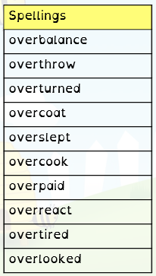

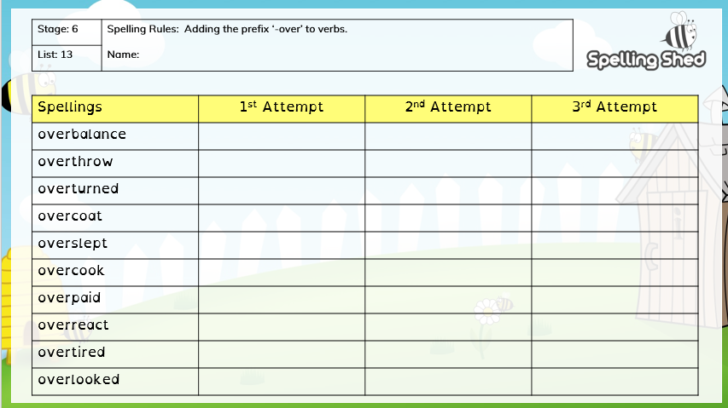
Tuesday:

Wednesday:

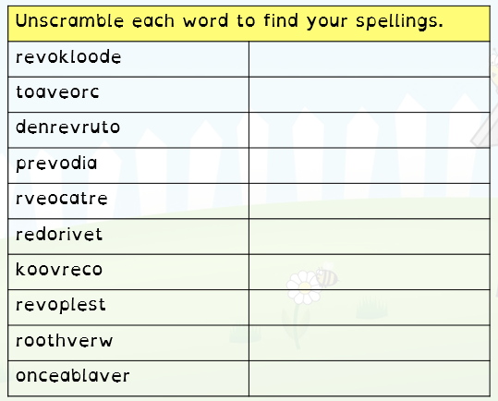

Thursday:

Practise your spellings by firstly writing them and then write them backwards

Friday:

We will be doing our test in school today … ask someone to test you.

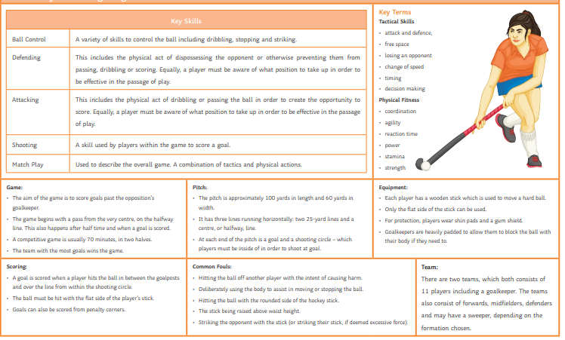

Outdoor PE

