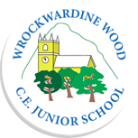
Wrockwardine Wood CE Junior School MEETING RECORD

Report of: Arts Council
Date: 24.10.23
Present: | 3B – Esme  3LB – Maisie  4C – Elliott  4T – Isabella  5H – Tommy  5B -  5/6S – Esme  6J – Seren L  6S – Max W  Adult – Miss Byrne
Topics covered on the agenda | - Art in school  - Competition  - Visits and visitors
Absent:
DECISIONS |  | ACTIONS  (Time related, budget implications) | ACTION BY
- Art in school |  | - It was suggested that there are more art resources bought such as more paint colours and more brushes. They would like the chance to help do the stock orders when they are done | - Audit the resources in school – arts council to help HB  - Ask what is frequently used
- Competition |  | - Arts council have agreed that they will run some competitions and will judge the first competition.  - Art council members to submit examples of photographs they have taken as inspiration for classes to be involved. | - Created a competition poster with HB  - Arts council members fed back to individual classes  - Posted on the newsletter and class dojo
- Visits and visitors |  | - Children have loved the opportunities in the past to visit art galleries and would like another opportunity of this in another year group.  - Arts council suggested that there should be opportunities to work with artists. | - Liaise with KS about another year group visiting a gallery now that 3/4 class is not active this year.  - HB to contact local artists to come and work in our school.
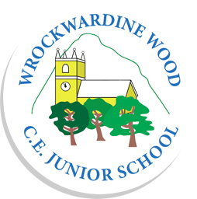
Date of next meeting: December 23

