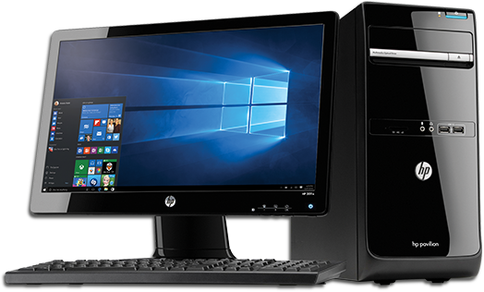

**Establish and develop the role of the new IT Technician.**

**To develop the use of Project Evolve alongside Teach computing to ensure pupils have the tools to keep themselves safe on line.**

**To develop assessment as part of the teaching of computing through the use of See Saw. Focus on how and when.**

**To provide CPD to support teaching staff and enable them to become more confident with the teaching of computing. Computing lead to disseminate courses attended.**

**To create a culture amongst pupils of remembering their passwords to expedite the logging on process.**

**Monitor the quality of teaching of computing**

**To teach pupils how to navigate See Saw and save work effectively and efficiently.**

**To develop the role of the computing group working alongside the safety squad.**

**To review the quality of devices and repair or replace when needed.**

**To embed the use of technology within lessons to develop cross curricular teaching.**

**To work with the Technician and LA to ensure the smooth running of technology across the school.**

**To embed the Teach Computing scheme of work and adapt to school context.**

Computing Pictorial summary 2023 2024