I'll have a glass of fruit juice in the morning, some vegetable stock in the evening and make sure to keep hydrated but otherwise I won't be eating anything at all.
More than 13 million people live in poverty in the UK, and up to 3.5 million of these are children.
Fasting has a strong and regular role in bringing the individual to a place where they understand their complicity in an unjust system and where they draw closer to God and to their neighbour.
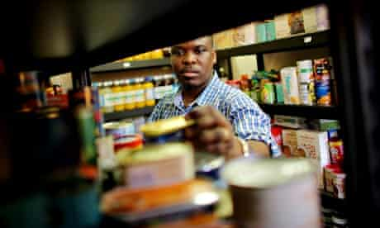
A time of study, prayer, my regular work and attempting to highlight the growing crisis of hunger in the UK.
Many are now dependent on food aid, relying on a rapidly expanding network of food banks.
People are skipping meals to better feed their children and 5,500 people were admitted to hospital in the UK for malnutrition.
When Jesus began his ministry of liberation for the poor and dispossessed, he spent 40 days in the wilderness and fasted.
Fasting can point the way to a greater compassion and help us demand that something be done to stop this crisis in its tracks.

