- Which multiples of 10 do the numbers sit between?
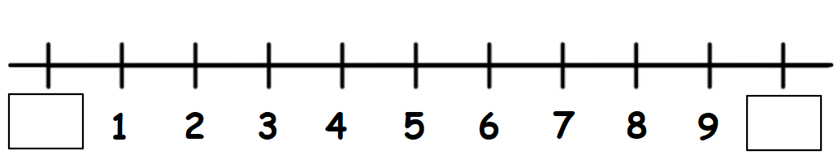
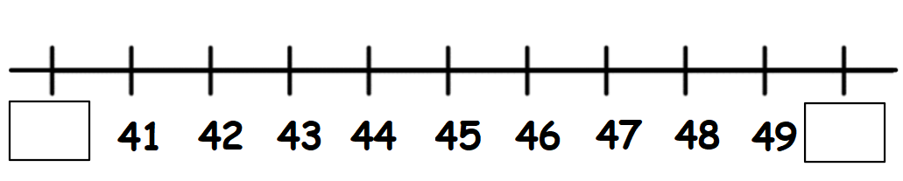
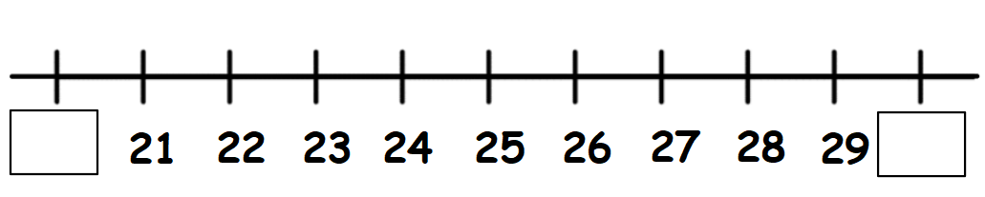
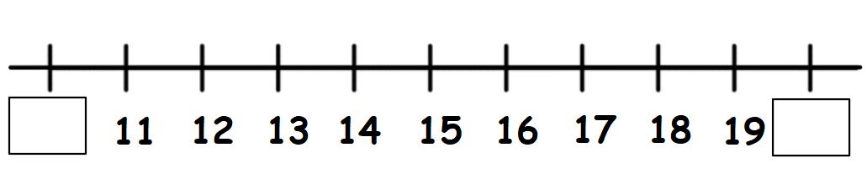
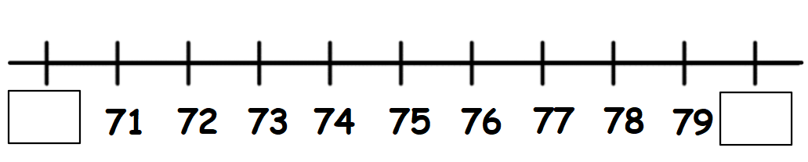
- Round each number to the nearest 10:
- 37
- 72
- 18
- 26
- 4

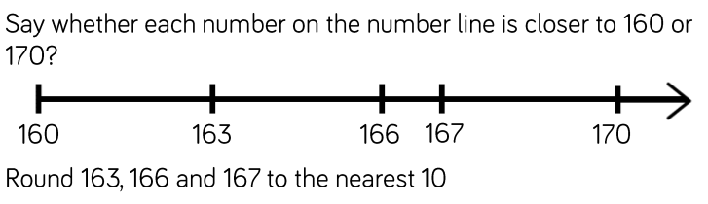

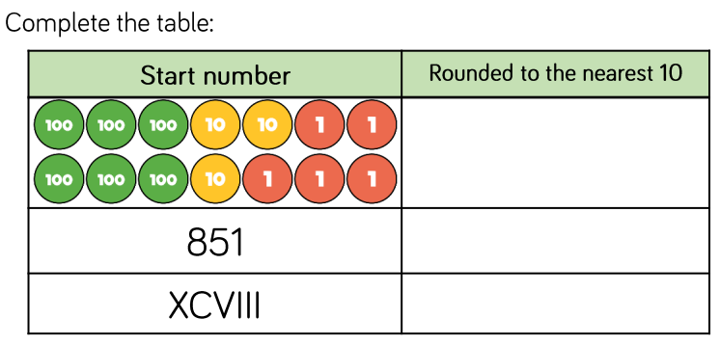

- Circle the numbers that will round to 480
489 479 471 481 475 485

____________________________________________________________________________

