R: What country is this video about?

I: What viewpoint are we seeing the country from? How do you know?

C: Which part of the country did you like best? Why?
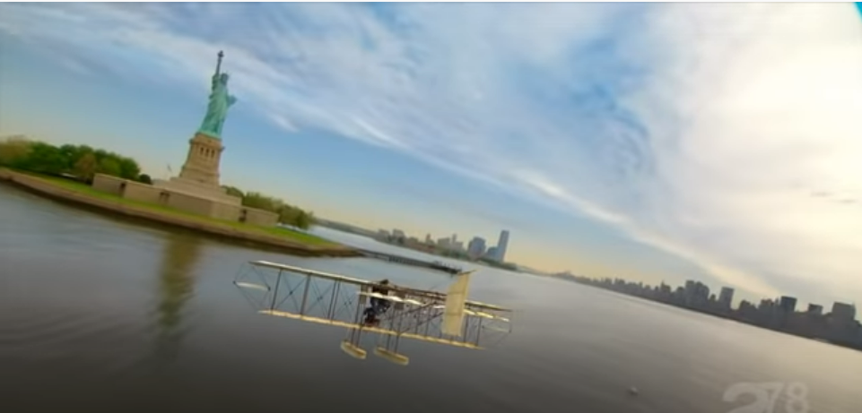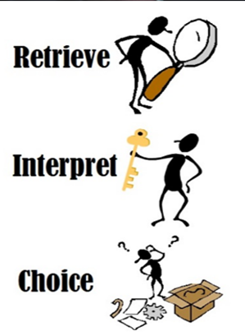

R: What country is this video about?

I: What viewpoint are we seeing the country from? How do you know?

C: Which part of the country did you like best? Why?

R: What country is this video about?

I: What viewpoint are we seeing the country from? How do you know?

C: Which part of the country did you like best? Why?

