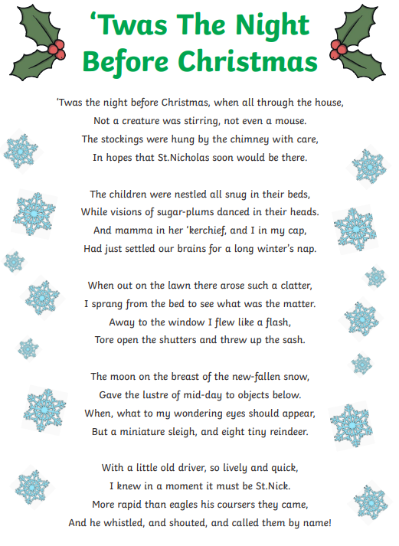

Use a dictionary to find our what these words mean:

Nestled

Miniature

