R: What were the children dreaming about?

I: Why did it look like daylight outside?

C: ‘I sprang from my bed to see what was the matter’. Why does the poet use the word ‘sprang’ here?
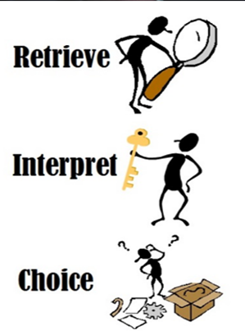

R: What were the children dreaming about?

I: Why did it look like daylight outside?

C: ‘I sprang from my bed to see what was the matter’. Why does the poet use the word ‘sprang’ here?

R: What were the children dreaming about?

I: Why did it look like daylight outside?

C: ‘I sprang from my bed to see what was the matter’. Why does the poet use the word ‘sprang’ here?

