Heading | 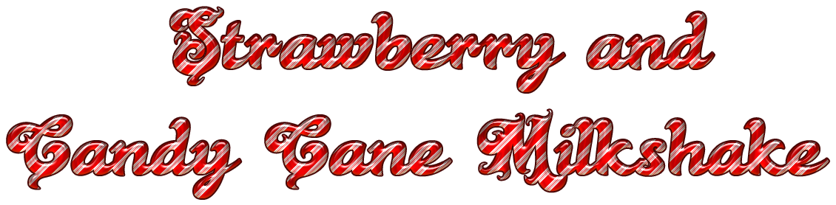
Sub-headings
Imperative verbs
Conjunctions
Adjectives
Adverbs

