Monday | Tuesday | Wednesday | Thursday | Friday
Love to read | Love to read | Love to read | Love to read | Love to read
Maths  Year 4 and Year 3  Aut3.12.1 - The 4 times-table on Vimeo | Maths  Year 3 and 4  Aut3.12.2 - Multiply by 8 on Vimeo | Maths  Year 3 and 4  Aut3.12.3 - Divide by 8 on Vimeo | Maths  Year 3 and 4  Aut3.12.4 - The 8 times-table on Vimeo | Maths  Use resources on the flipchart
Spelling | Spelling | Spelling | Spelling | Spelling
English  Features of a Haiku | English  Expanded noun phrases | English  A haiku of Autumn | English  A haiku of the Iron Man | Jigsaw –  See flipchart
Science  Electricity | Computing  e-safety | RE  Sikhism – To understand what it’s like to be in a Gudwara | 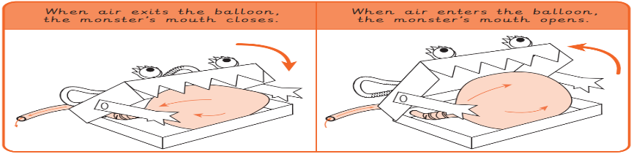  D and T  Create a moving monster  Can you make a moving monster? Place a balloon inside a box and inflate it to open the mouth.

Timetable for year 3 and 4 Week beginning 22.11.21

