Day | Maths | Love 2 Read |  |  |  | English |  | Afternoon sessions | Afternoon sessions | Spellings
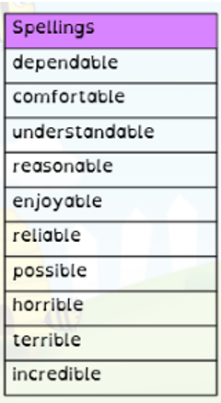
Spellings:

Choose one activity per day off from the spelling resources.

Log onto spelling shed for games.

Spelling Shed

Mon | LO: Mini Assessment  Resources on website | Answer the RIC Questions based on the video,  Key vocabulary sheet,  Resources and flipchart on website. |  |  |  | LO: To identify features of explanation texts.  Resources on website |  | DT  Planning a fair test,  Resources on website.
Tues | LO: To solve comparison, sum and difference problems using data.  Video and resources on website | Make inferences about the image and annotate.  Read the extract and answer the inference questions.  Resources and flipchart on website. |  |  |  | LO: To research how roller coasters work.  Resources on website |  | Forest School  If possible, go out into the garden and enjoy nature!
Wed | LO: To accurately read and interpret line graphs.  Video and resources on website | Love to Read  Read for pleasure |  |  |  | LO: To write correctly punctuated sentences using subordinating conjunctions.  Resources on website |  | . Outdoor PE  Pretend you’re the dribbling a ball and someone is coming towards you, trying to get the ball.  Move your body tactically to escape the person coming after your ball! | Science
Thurs | LO: To represent data in a line graph.  Video and resources on website |  | Write a diary entry as Stan now that he has run away with the fair.  Resources and flipchart on website. |  | LO: To link cause and effect using causal conjunctions.  Resources on website |  | Computing  Log on to Timestable Rockstars! |  | DT  DME LO: To design a ride using given criteria.  Resources on website.
Fri | Arithmetic  .  Resource on website. | Write your own inference questions based off the cover of the book.  Resources and flipchart on website. |  | MFL  French Number Matching activity  Resource on website |  | Jigsaw  To understand what racism is.  Resources and flipchart on website. |  | RE  To learn about becoming an Amritdhari Sikh.  Resources and flipchart on website. | Indoor PE  Put on your favourite music and move your body as much as you can.  It doesn’t have to be lots of dancing, even just tap your feet. | Worship:  Monday and Tuesday have a small Worship activity.  Resources on website.

