What is the picture of?
Why is the goldfish shown like this?
Why did the illustrator make this picture?
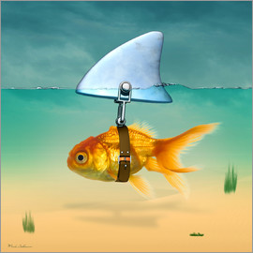

What is the picture of?
Why is the goldfish shown like this?
Why did the illustrator make this picture?

What is the picture of?
Why is the goldfish shown like this?
Why did the illustrator make this picture?

