Wrockwardine Wood CE Junior School
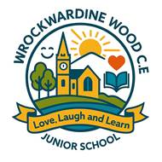

School Uniform Policy
2026-2027

Updated: February 2026
Review Date: February 2027
Signed T. Cartwright

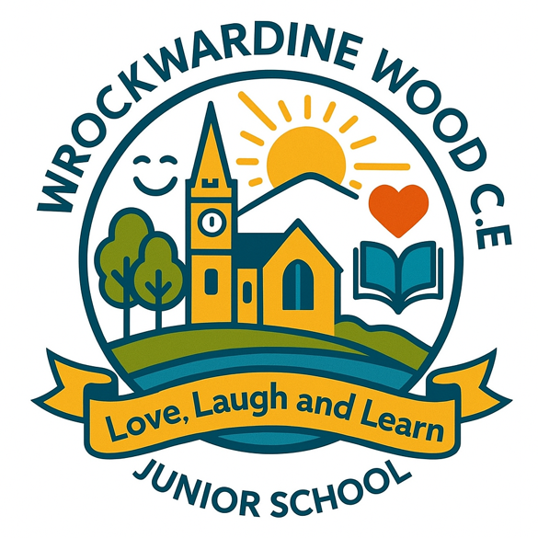

“Love, Laugh Learn”

We will ignite the ability in all to ‘Love, Laugh and Learn’, recognising the extraordinary and wondrous in everything and in everyone. Our rich, varied and creative curriculum, together with our Christian values, will empower all to flourish following Jesus’s promise ‘I have come to give life and life in all its fullness.’ (John 10:10)

Our School Christian Values




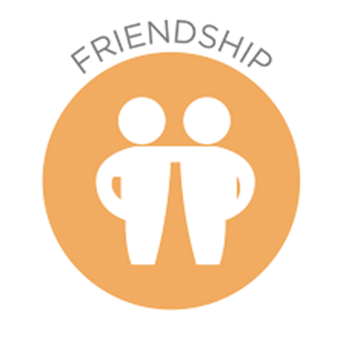



We want our children to look smart when at school and feel proud to wear their uniform. The Governing Body of Wrockwardine Wood CE Junior School have agreed that school uniform should be worn at all times in school.
Our uniform policy is outlined below. We expect all our children to wear a school sweatshirt or cardigan carrying our logo. School sweatshirts or cardigans with the school logo on can be purchased via ParentPay. We try our best to keep the cost as low as possible for these items.
Please note that all children will need to wear black shoes unless on a PE day when they will be asked to come into school in their PE kit/trainers for the whole day.
Main Uniform
• Black or grey skirt or pinafore dress. Skirt should be knee length
• Black or grey trousers or shorts
• White polo-shirt or shirt
• Blue school sweatshirt or cardigan with school logo or without
• White knee length or ankle socks for girls, grey tights in winter
• Grey or black socks for boys
• Black shoes or black boots in winter – very low heels
• Navy blue checked summer dress
Incorrect/inappropriate Uniform
If a child comes to school in uniform which is not school policy, then the school uniform policy will be followed (see separate policy). In the first instance, the child will be reminded of the correct uniform and a letter sent home to parents. If the child continues to wear incorrect uniform, then their parents will be called to discuss this. Children will be offered alternative school provided uniform to wear for that day. If a child wears inappropriate uniform (football kits, T shirts with slogans or clothing which exposes the midriff/or is too short), the parents will be called immediately and asked to bring in alternative uniform or give permission for their child to borrow uniform provided by school. If the inappropriate uniform is not corrected, the child will not be allowed in the class.
In exceptional circumstances, an agreement can be made by speaking directly with the Headteacher.
PE kit– to be worn to school on PE Days
• White plain t-shirt
• Blue shorts or skort (no branding)
• Plain navy-blue sweatshirt or PE top with school logo and tracksuit bottoms/leggings (no zips, hoodies or branding)
• Trainers
• Football boots (optional) – as plain as possible

If a child’s kit is forgotten regularly, you will be notified by letter or telephone.
Hair, jewellery and accessories
• No jewellery allowed except for a watch and only small, plain studs if children have pierced
ears. These need to be removed by the child during PE.
• Watches – to be analogue or digital. No smart watches. Fitbits are allowed.
• Hair accessories are to be kept to a discreet minimum and in navy blue - neither large bows nor
headbands with decorative pieces are allowed.
• Dyed hair or shaved tramlines are not allowed.
• Nail varnish/false nails or acrylics should not be worn in school.
• Temporary skin tattoos are not permitted

We reserve the right to confiscate items that are being worn or used inappropriately and can ban unforeseen items that may come under ‘fashion’ items that are not specifically stated in our uniform policy.

Other items
Children need a coat for school, school bag, wellies for Forest School and in the summer need a sunhat –all to be provided from home and named.
Pre Loved
We have a number of preloved uniform items that have been donated to the school by parents. If you would like any pre-loved uniform please contact the school office detailing the items you would like and the size, if we have anything that matches your request we will send it home with your child, or you can collect it.
Please ensure that all items of clothing are clearly labelled with your child’s name to ensure they can be returned to you if misplaced.
Please also encourage your child to be responsible for their own items of clothing/personal items and to check lost property if they have lost anything.

School Uniform and SEND
The Governing Board is aware of the needs of pupils with SEND and will work collaboratively with the Headteacher and SENDCO to consider appropriate flexibilities, adaptations, adjustments, or alternatives that could mitigate any negative impact on these pupils, regarding school uniform. Any request for adaptations should be made in writing to the Headteacher for referral to the governing body.

