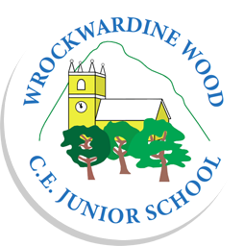
Wrockwardine Wood CE Junior School
Uniform Order Form

Item | 7/8 Years | 9/10 Years | 11/12 Years | 13 Years | Small Adult | Med Adult | Total
Sweatshirts  Royal Blue - £10 | ___ | ___ | ___ | ___ | ___ | ___
Girls Cardigans  Royal Blue - £12 | ___ | ___ | ___ | ___ | ___ | ___
Royal Blue Book Bags with School Logo - £5
Royal Blue P.E.
Bag with School
Logo - £5
White Polo Shirts - £8 | 7/8 | 9/10 | 11/12 | XS Adult
T-Shirts for P.E. - £6 | 7/8 | 9/10 | 11/12 | 12/13 | 14/15
Total

Please enquire at school office if smaller or larger sizes are required.
Payment is due with order. Make any cheques payable to WROCKWARDINE WOOD C of E JUNIOR SCHOOL.

CHILD’S NAME…………………………………………………………………….....CLASS……………...

(Where possible, orders will be processed the same day and handed to the child. If items are out of stock, a 2 week wait is usual.)

